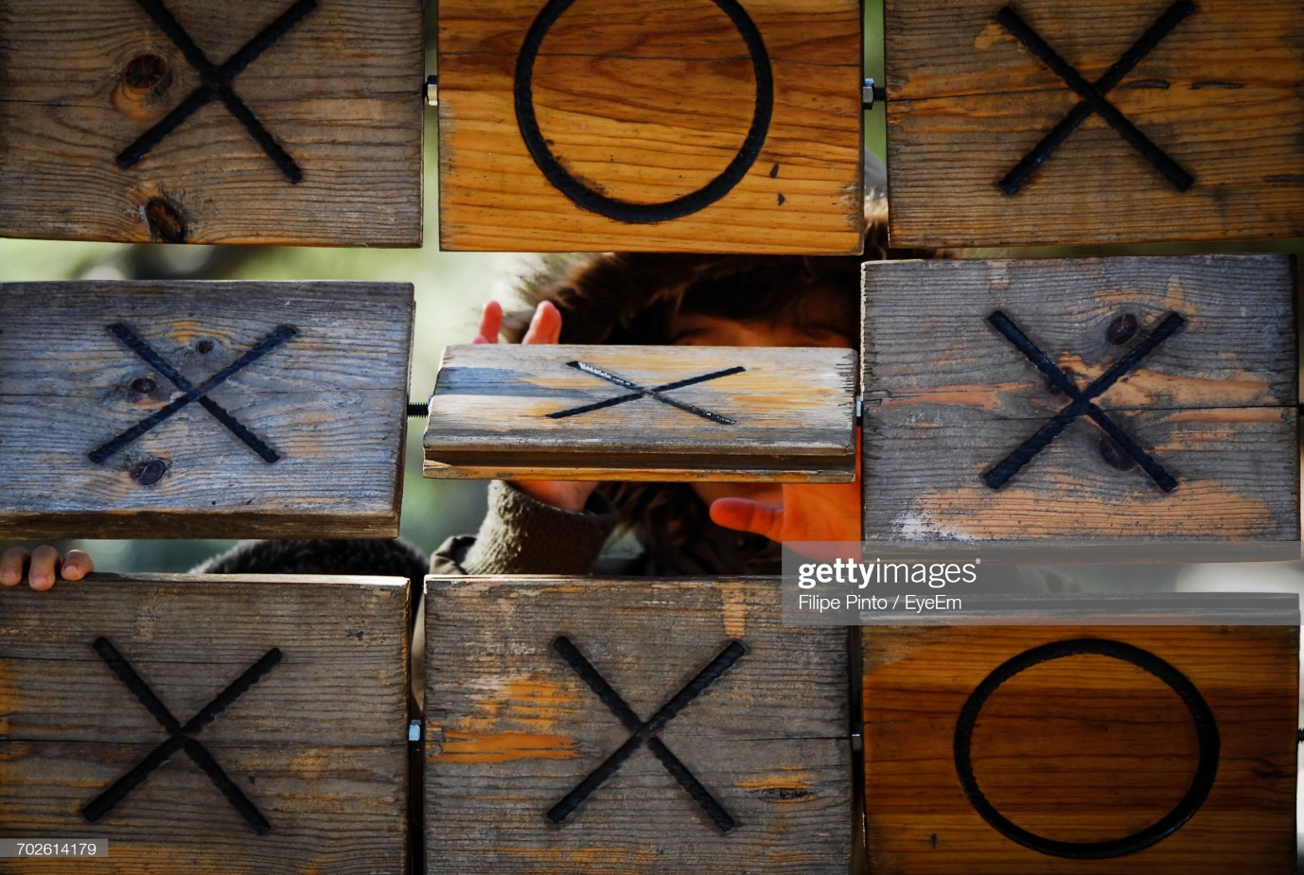Tic Tac Toe Ultimate :

Guide Book

H.D.M.Perera

18/ASP/163

**User Manual**

1.How to open the game :

* Open the Tic_Tac_Toe_Ultimate_Game.jar in the Tic_Tac_Toe_Ultimate_Game\dist
* Then Open like this interface





click For new game click for continue

2.Enter the player’s names :

* 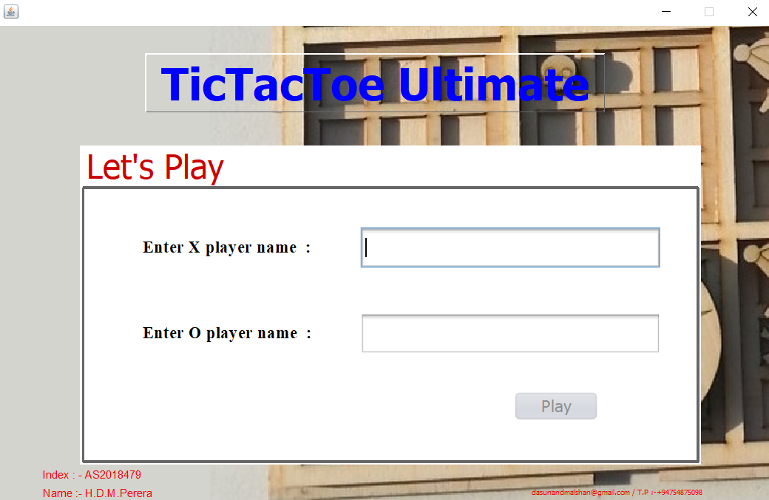

Enter X Player’s name Enter O player’s name

* After click play button.
* Now you were going to this interfase.
* 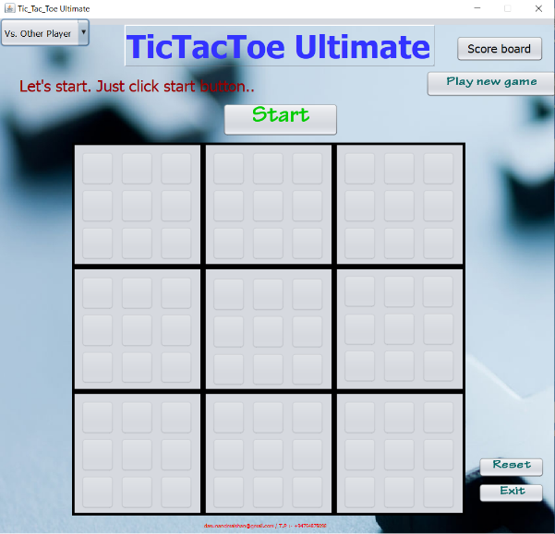

3.Play game and game rules :



* Now click the start button.
* Then player’s names will be enter like this.
* 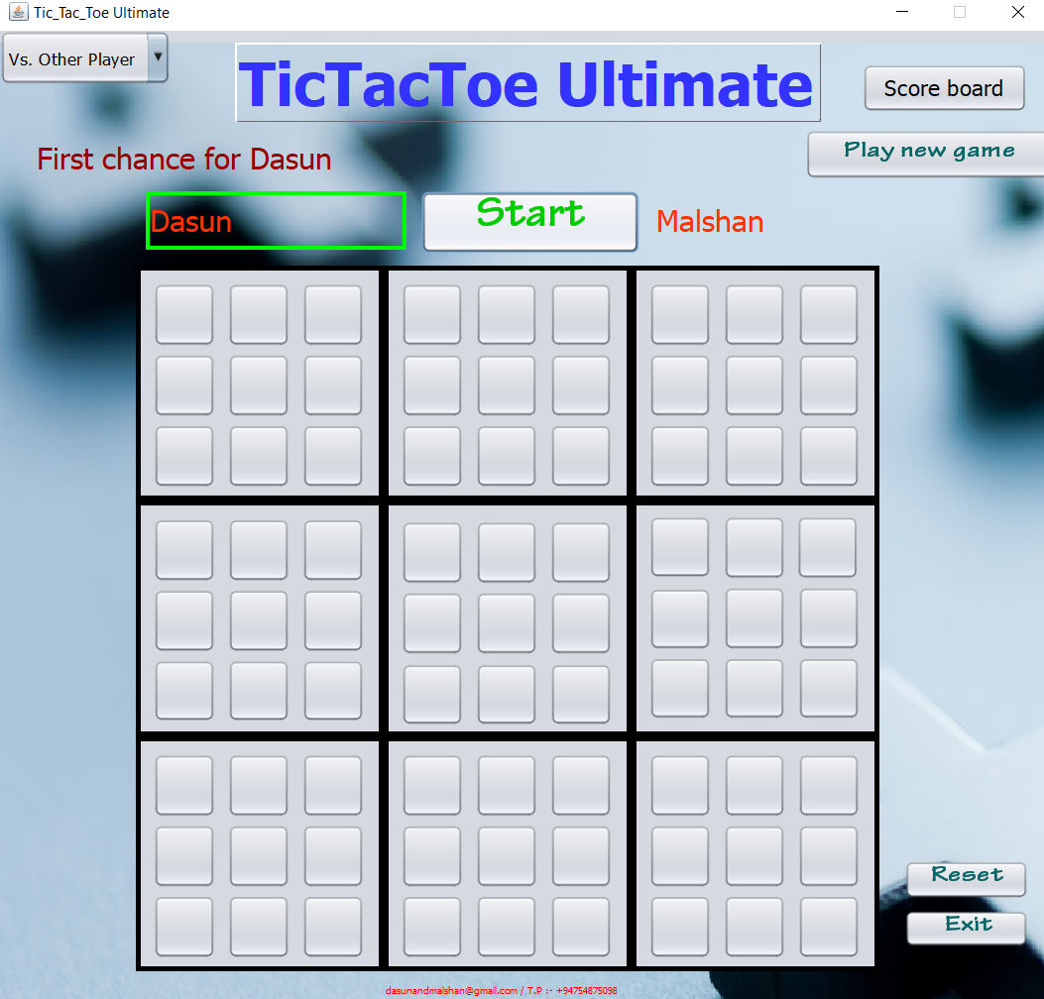
* The game starts with X playing wherever they want in any of the 81 empty spots.
* This move 'sends' their opponent to its relative location. For example, if X played in the top right square of their local board, then O needs to play next in the local board at the top right of the global board, as shown in Figure 1.
* Figure 1:

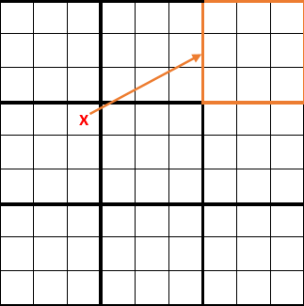

* O can then play in any one of the nine available squares in that local board (with the orange border in Figure 1), each move sending X to a different local board. For example, if O marks the bottom middle square then X has to be marked in the bottom-middle local board as shown in Figure 2.
* Figure 2:

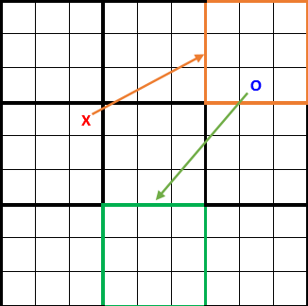

* If a move is played so that it is to win a local board by the rules of standard TicTacToe, then the entire local board is marked as a victory for the player in the global board as shown in Figure 3.
* Figure 3 :

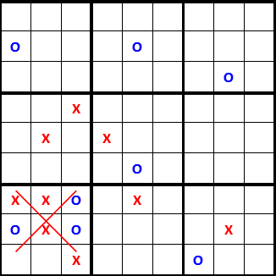

* Once a local board is won by a player, or it is filled completely, no more moves may be played in that board. If a player is sent to such a board, then that player may play on any other local board. See such a case in Figure 4.
* Figure 4:

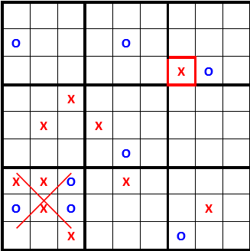

* Game play ends when either a player wins the global board, or there are no legal moves remaining, in which case the game is a draw.

4.Game board option :

01

* 

02

03

04

1. Score board button

* To find score,X and O players.

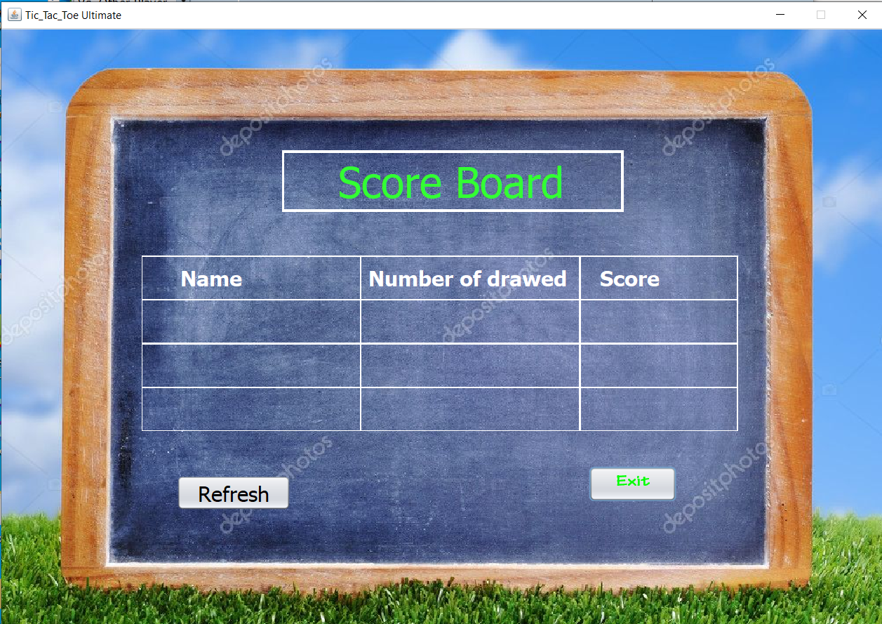

**Scoring scheme**

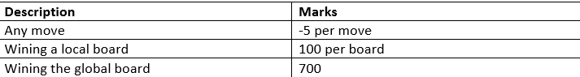

1. Play new game button

* For play new game for new players.

1. Reset button

* Reset score board for play again.

1. Exit button

* Game saved and exit.

**Thank You!**